Name Surname:Furkan Özer Date:31/10/2025
Number:2023555067 Report No:04
Digital Design Lab Report
Homework / Lab
Parts of Report:
- Description: F(A, B, C) = Σm (1, 2, 5, 6)
Design a 4x1 mux for given function with VHDL codes. Simplify the function. Explain how to make compilation and simulation. Show the simulation results.

- Turth Table of Design
A | B | C | Y
0 | 0 | 0 | 0
0 | 0 | 1 | 1
0 | 1 | 0 | 1
0 | 1 | 1 | 0
1 | 0 | 0 | 0
1 | 0 | 1 | 1
1 | 1 | 0 | 1
1 | 1 | 1 | 0

- Drawing the circuit of desired desing

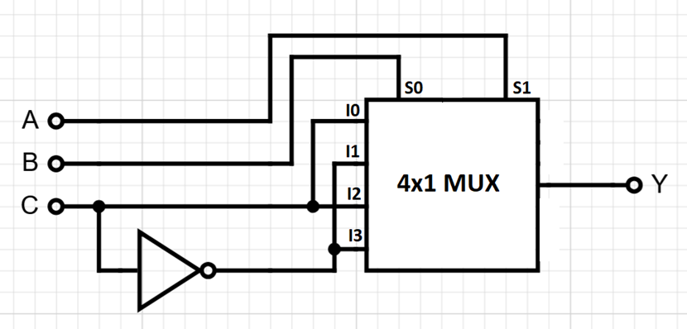

- Steps of Lab/Homework :
library IEEE;
use IEEE.STD_LOGIC_1164.ALL;

entity mux4x1_func is
Port (
A, B, C : in STD_LOGIC;
Y : out STD_LOGIC
);
end mux4x1_func;

architecture mimari of mux4x1_func is
signal S : STD_LOGIC_VECTOR(1 downto 0);
begin
S <= A & B;

process(S, C)
begin
case S is
when "00" => F <= C;
when "01" => F <= '1';
when "10" => F <= C;
when "11" => F <= '1';
when others => F <= '0';
end case;
end process;
end mimari;

- Simulation Results: Here you will show the simulation drawing

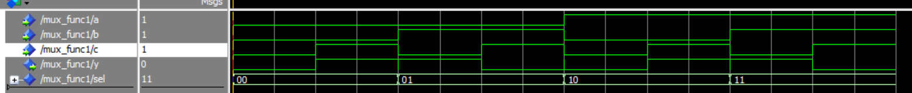

Conclution: The desired circuit is obtained. We design the function to be a mux. A and B are selection inputs and C is the data input. Depending of the A and B, output is C or C’. As you see the simulation result, wanted truth table is obtained.

